Bracebridge Out of the Cold
705 644-3761
New Thursday night Dinners
**Monthly, on select nights only see below**
The Bracebridge Salvation Army along with the Rotary Club of Bracebridge Muskoka Lakes would love to have you join us!!
For a free hot and nutritious meal in a caring and confidential atmosphere
Thursdays:
2019
January 24
February 28
March 28
April 25
May 23
June 27
2018
October 4
November 1

Location: Bracebridge Salvation Army Community Church
456 Manitoba Street
Doors open at 5:00 pm, Dinner served at 5:30 pm
All Welcome
Bracebridge Out of the Cold Bus Schedule
Young & Shier Street (near Wally’s garage) – 4:30 pm
Cedar Lane Motel lower parking lot – 4:35 pm
McVittie Place – 4:40 pm
Alice Street Apartments – 4:45 pm
Aubrey Street Apartments 4:50 pm
Oakwood Heights – 4:55 pm
Wellington Street Housing Units (front of # 10) 5:00 pm
Theatre Parking Lot (Manitoba Street) – 5:05 pm
19 Monck (parking lot behind building) – 5:10 pm
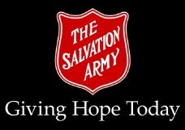
School bus cancellations apply

