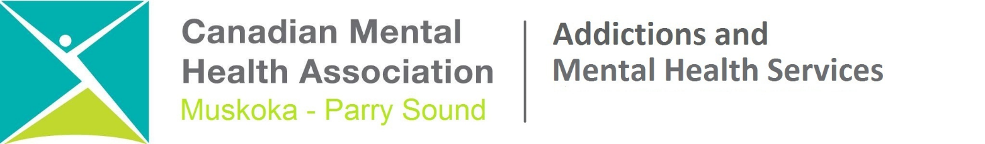

INTERNAL/EXTERNAL POSTING: May 10, 2018 – May 18, 2018

ABORIGINAL MENTAL HEALTH AND ADDICTIONS WORKER
B’SAANIBAMAADSIWIN PROGRAM

Job Status: Contract to September, 2018

Hours of Work: 35

Base office: Parry Sound

Purpose of the Position: To provide mental health and addiction support to the Aboriginal population (First Nations; Metis and Inuit) of the Districts of Muskoka and Parry Sound.
Education and Qualifications:

- A Bachelor’s degree in Health/Social Sciences or equivalency with a minimum of 1 year experience working with individuals with mental health and addiction issues in the areas counselling, crisis intervention and community development interventions.
- A clinical degree (usually Master’s level) in Psychology or Social Work and/or are a Registered Nurse with experience in the area of serious mental illness or equivalent (equivalency qualifications may be granted based on a combination of education and experience)
- Membership or application for membership with a professional college that grants the authority to practice psychotherapy in Ontario
- Aboriginal cultural education and awareness is an asset.
- Ability to be sensitive to and be seen to be sensitive to Aboriginal history and its impact on the current health status of the consumers and the communities.
- Sound theoretical and practical knowledge and skills of better practices in the areas of counselling; crisis intervention; trauma informed care and community development.
- Ability to communicate effectively, both verbally and in writing with consumers, colleagues and other members of the community.
- Clear Criminal Record Check, including Vulnerable Sector Screening.
- Willingness to travel within the Districts of Muskoka and Parry Sound
- A valid Ontario G or G2 driver’s license and a safe and reliable means of transportation

Major Responsibilities:

- Establish and maintain appropriate working relationships with key players in each First Nation community and externally as dictated by the needs of the program. Aboriginal communities and Non Aboriginal service providers.
- Provide assessments, referrals, follow-up and treatment planning for individuals, couples and families in collaboration with community workers as agreed upon by consumers.
- Provide crisis intervention, crisis support and consultation to consumers and community stakeholders to stabilize the current situation.
- Participate in an after-hours on-call crisis service as required and assist with the team’s implementation of the 24/7/365 crisis service.
- Provide individual, family and group counselling which utilizes both cultural and mainstream approaches in the treatment of mental health; addiction and concurrent issues.
- Provide case management support as needed.
- Participate in community education and community development activities as required.

Salary scale: $27.01 to $35.16 per hour.

Please note that we are scent-free facility.

Canadian Mental Health Association Muskoka – Parry Sound (CMHAMPS) is an equal opportunity employer and we value the importance of diversity, dignity and worth of every individual in the workplace.
Qualified consumers/survivors and/or family members are encouraged to apply.
We retain all applications submitted for one year after the closing date of this posting for consideration in any future postings.
As part of our commitment to accessibility, if you wish this information in a different format, please contact our office at 705-645-2262 or email feedback@cmhamps.ca. If you are contacted regarding a job opportunity, please let us know prior to the interview if you require accommodation.

We thank all applicants but only those selected for an interview will be contacted.

You are invited to submit your application by 4:30 p.m. on May 18, 2018 , to:

The Hiring Committee
Canadian Mental Health Association, Muskoka-Parry Sound Branch
173-202 Manitoba Street
Bracebridge, Ontario P1L 1S3

Telephone: (705) 645-2262 Fax: (705) 645-7473 Email: jobs@cmhamps.ca

