Mon. Dec. 16, 2019  5:00pm to 7:00 pm  Family Peer Support Group  Council of Consumer/Survivor and Family Initiatives Program  Are you a family member or support person of someone living with mental health issues? Then this group is for you!  The Family Peer Support Group provides support and education to family members/care givers who are supporters for individuals with mental health issues.  We provide a safe, non-judgmental environment for growth, healing and information.  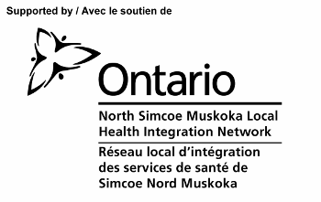  Schedule is subject to change | Location  CMHA Muskoka- Parry Sound  Room 213  60 James St, Parry Sound  ────  Share your story, your struggles and your coping strategies  ────  We all need someone to talk to  Let’s work together  ────  Canadian Mental Health Association – Muskoka Parry Sound  Please contact for more information:  Valerie Kitchen at  705 384 5392 ex. 4228  Kathy Stevenson at  705 384 5392 ex. 4280

