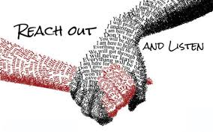  May 9, 2019  June 13 ,2019  July 11 , 2019  August 8 , 2019  from 6:00pm to 8:00 pm  Family Peer Support Group  Council of Consumer/ Survivor and Family Initiatives Program  Are you a family member or support person of someone living with mental health issues? Then this group is for you!  Family Peer Support Group provides support and education to family members/ care givers who are supporters for individuals with mental health issues.  We provide a safe, non-judgmental environment for growth, healing and information.  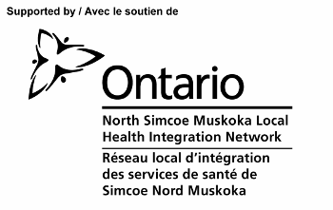 | Location is at 250 Clark Street, Powassan Upper Meeting room CEDAR  ────  Share your story, your struggles and your coping strategies  ────  We all need someone to talk to  Let’s work together  ────  Together we can achieve anything!!  Canadian Mental Health Association – Muskoka Parry Sound  Please contact for more information  Kathy Stevenson at  1-705-384-5392 extension 14280  kstevenson@cmhamps.ca

